## ****What is resource group in Azure****

A **Resource Group** in Azure is nothing but a logical container where you are creating your **Azure resources**. That holds all

your **Azure Resources**. A **resource group** created in a specific region can contain the resources created in the other

regions. There is no restriction on that.

**Resource groups** are also called the central unit that acts like a logical container that holds all the Azure resources.

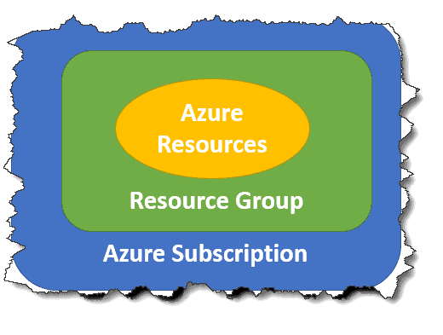

**What is the purpose of a resource group?**

Resource Groups in Azure is the approach to group the collection of resources that helps for easy maintenance of the  
  
Resources for example easy monitoring, automatic provisioning, etc. This is the main Purpose of the ResourceGroups.

Behind the scene, **Azure Resource** **Manager (ARM)** is technology that helps Azure for the activities.

## ****Do Azure resource groups cost money?****

The answer to this question is absolute **No,** There is no price for the**Resource Group**. You need to pay for the resources

as per the pricing model. So you need to pay for the resources, not for the **Resource Groups**.

## ****Why do we need resource group in Azure?****

A **Resource Group** is a logical container that stores the metadata of the resources that helps for the administration activities

and the **cost management** of the group of resources and also helps for the easy management of the role-based access.

**Azure resource groups - Imporantant points to remember**

1. An azure resource is any service instance that you create. For example, virtual machine, Azure sql database, storage account etc.
2. A resource group, as the name implies, a group of related azure resources.
3. In general, resources in a resource group share the same life cycle, so they can be easily created, deployed, updated, and deleted as a single unit.
4. When you create a resource group, you specify a region. It is this region where the meta-data about the resource group is stored.
5. However, the resources themselves can be in any azure region.
6. Resources in one resource group can interact with resources in other resource groups.
7. Each resource must be in one and only one resource group. You cannot have a resource in more than 1 resource group at the same time.
8. You can move a resource from one resource group to another.
9. You can add or remove a resource from a resource group at any time.
10. You can group resources any way you want. Anyway that makes sense to your oragnisation really - By department, By country, By application, By resource type or a combination of these.